CREATE & CONFIGURE IBM CLOUD SERVICES CREATE TEXT TO SPEECH SERVICE

|  |  |
| --- | --- |
| **Date** | 17 November 2022 |
| **Team ID** | PNT2022TMID24184 |
| **Project Name** | Personal Assistance For Seniors Who Are Self Reliant |

# Installation of Watson-TTS Client library Provided for Python:Code:

pip install --upgrade "ibm-watson>=6.1.0"

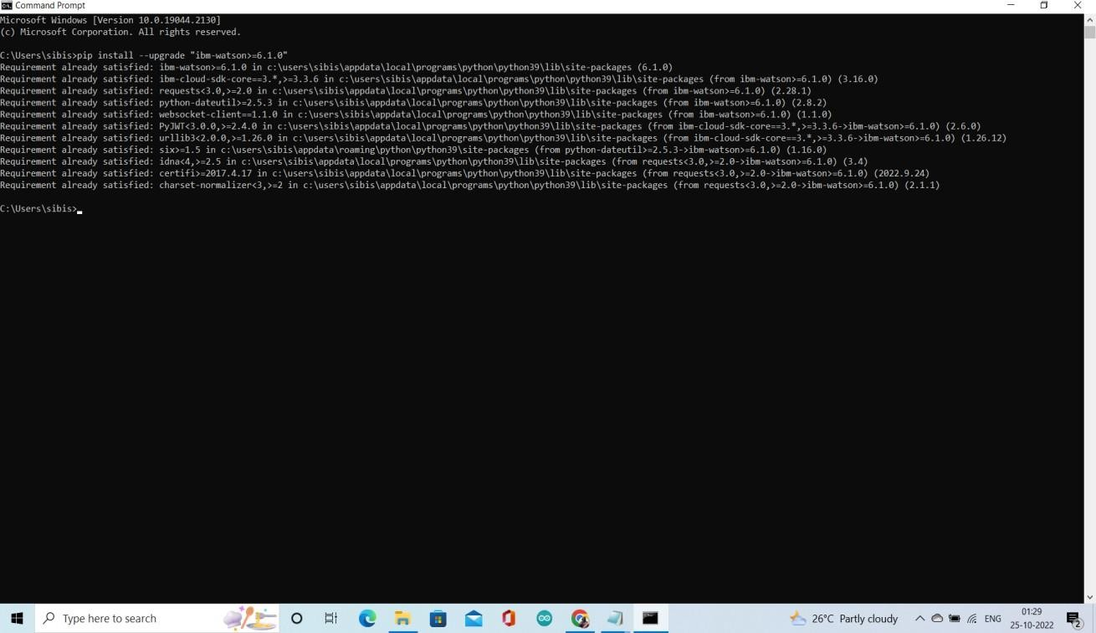

# Service Creation Status & Credential Details:

**STATUS:** ACTIVE

Execution & Test Run of Program to Access TTS:

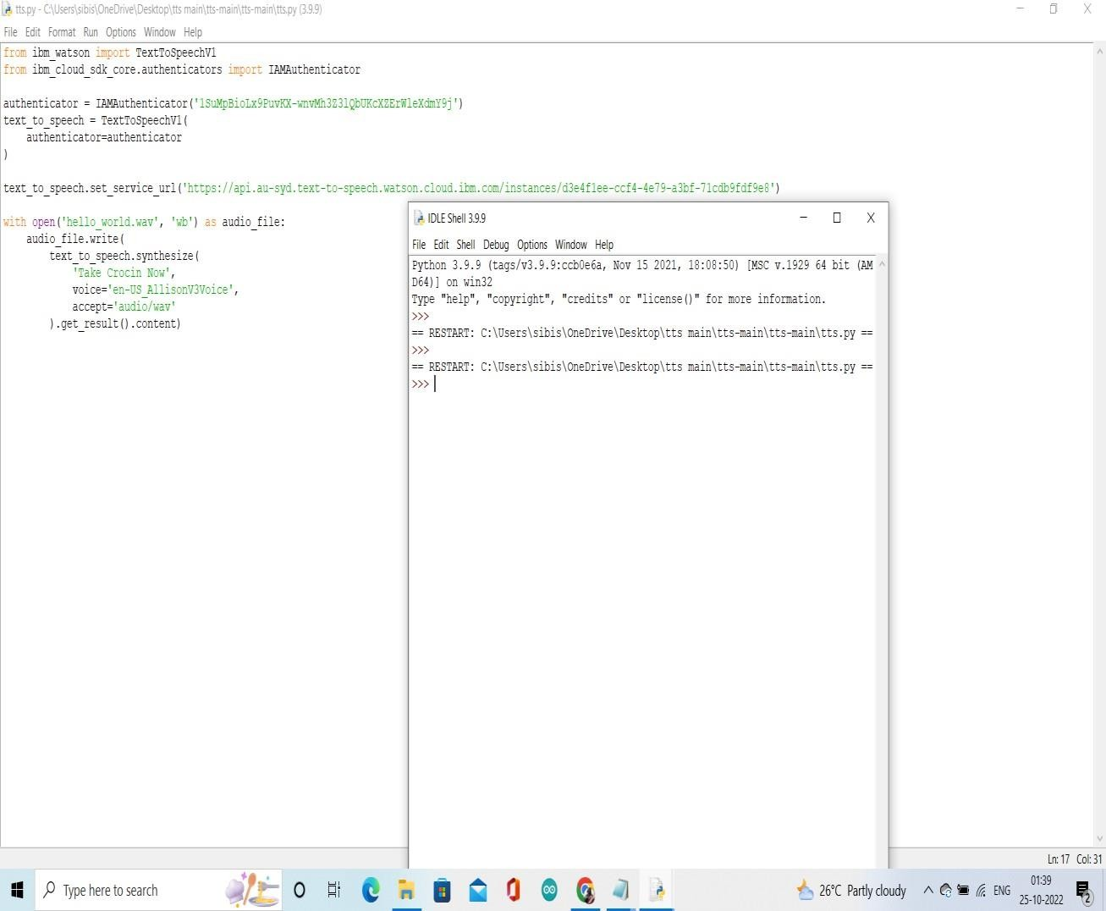

**RESULT:** SUCCESSFULLY CREATED.